Bement Farmstead
By Mia Ku
On Thursday, May 5th my class and I went to the Bement-Billings Farmstead Museum. We were with our KDT buddies from Northeast, and the teachers split us up, with everyone in the same group as their buddy. There were 5 rotations: The Blacksmith’s Shop, The Kitchen, The Quilting Room, The Woodworking Shop, and The School/Barn. The lady at the Quilting Room rang a bell to signify a rotation.

Our group went to the Blacksmith’s Shop first. The Blacksmith’s Shop was very dark. There was a small fire powered by a HUMONGOUS bellow, a tool that pumped air into the fire, making the fire bigger. When we went into the Blacksmith’s Shop, we saw him stick a piece of metal into the red-hot fire, making the tip come out glowing. He then took it to the anvil and started hammering at the glowing tip. Then he went to the wooden lever and pumped the bellow, making the fire ( which had grown dim) pump back to life. I noticed that there was a hole in the wooden roof, right above the fire, to let the smoke escape. He told us that he not only made horseshoes, but actually knew how to fit them on the horses. He also let us hold many of the objects that he made, his tools, and objects that other blacksmiths made (both tools and pieces of art). He said that many of the objects that blacksmiths made back then, were for the kitchen. He showed us some old-fashioned kitchen-ware, and told how the people who lived on the farmstead used the tools. It was very cool! 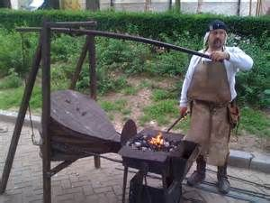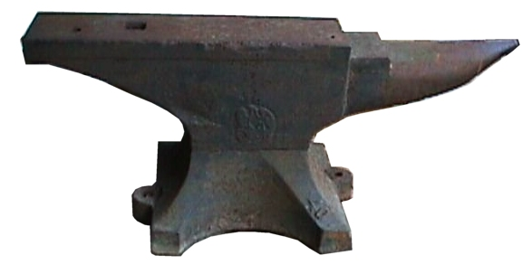

Next, we went into the house. We looked at the Butler’s Pantry first, then went to the kitchen. In the Butler’s Pantry, there were so many tools! My favorite was the butter churner, which just looked like a barrel and a wooden pole. In the kitchen, there was a big window, a fireplace, many candles, a candle-lit glass light, beehive ovens (I’ll explain these later in the paragraph), another two doors (one to go outside and one to go upstairs, both were off-limits), a very old table, some chairs, and a cupboard filled with brownish - reddish dishes. The lady at the kitchen said that the beehive ovens were made so the mother could bake a lot of food, like pies and bread, very quickly. She showed us their type of toaster (because they didn’t have electricity, of course), and how they used it. She also explained the wide variety of meat they ate, because they had so many wild animals in the forest and the creek nearby, and the farm animals. While she talked, we took turns churning some half-churned butter that we would take back to school after it was fully churned. At the very end, we ate delicious cornbread, baked by a retired volunteer. Yum!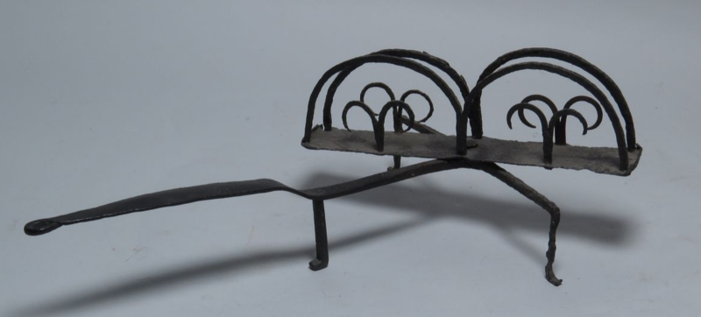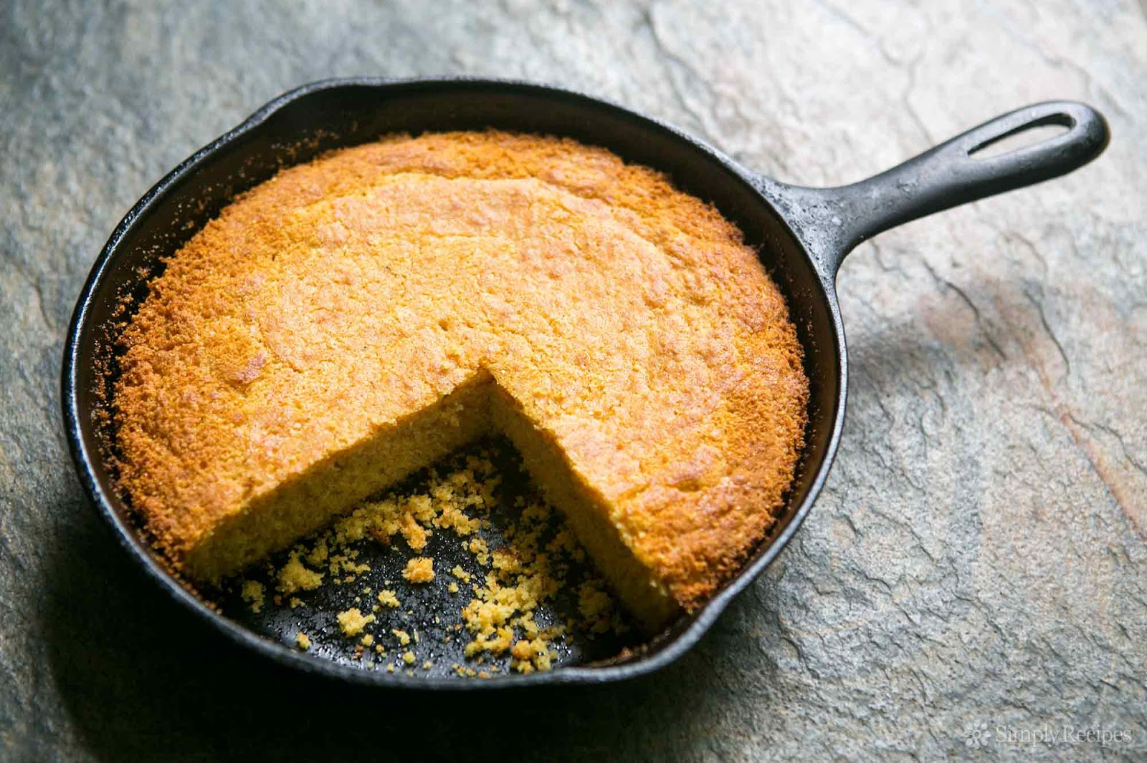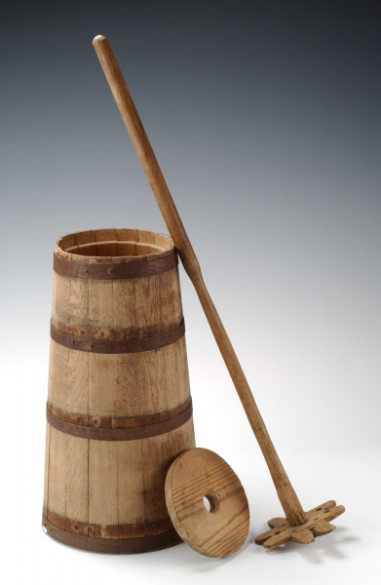

After we finished our cornbread, we went to the Quilting Room. There was a whole table covered in quilt scraps that were cut into squares. We learned about many common patterns that the Bement family used for their quilts. We even got to see some of the quilts that the Bement family made! Then we cut some of the quilt squares and glued them on a piece of paper to create a very nice pattern called the friendship star. Then we got to explore the rest of the first floor, even though the rooms were all roped off. There was a living room with a fancy couch and fancy chairs and even a fancy stove just for guests! There were two bedrooms on the first floor, and both had HUGE beds with quilts made by the Bement family. I thought it was really cool how they had farm-based murals painted all over the walls. I also really liked how they put the cabinets in the wall. Really! There was a small handle on the wall and if you pulled on it, you opened up a huge cabinet! SO COOL!!!!!!

Right after the rotation bell, my group and I went to the Woodworking Shop, a small wooden hut that had no doors, just a big opening in the wall. There were hammers and nails set on the long, thin wooden table built into the wall. There was one small window overlooking the grassy meadow that used to be a tight forest. The man showing us around the woodworking shop showed us a lantern. It was a tin can bent down at the top, and it had intricate designs punched into the tin. The lantern was lit by a long candle put inside the lantern. The man was really funny, so he told us we were going to do tin punch with the ‘computers’ behind us (it was actually just a hammer, a nail, and a slab of wood). Then he gave us each a square of tin with a heart drawn with connected dots on the tin. We used our nails and the hammer to punch through the tin aiming at the dots, creating the heart shape. While we were working, he showed us a toy that the children who lived back then would have played with. But he didn’t use the name of the toy, because he called it an ‘Xbox’! After we all finished Caesar asked what the bench sitting in the middle of the room was for. The man said it was called the Discipline Bench and was made to get children to pay attention. Then he showed us a game where you pull strings to have little wooden creatures (anything and/or anyone you want) climb up to the top of the rope. Whoever got there first was called the Winner and got to sit in the front of the room. The loser was called the Whiner and had to sit in the back of the room.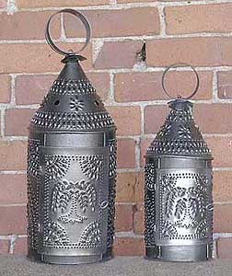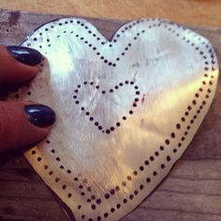

At the last rotation, we went to the Barn/Schoolhouse. The Bement family didn’t have a schoolhouse so they put benches in the barn and hired a teacher. At the schoolhouse the lady gave each of us a slate and a piece of chalk. She told us that because they didn’t have whiteboards, they used chalkboards instead. She also said that since the Bement family couldn’t afford to get chalkboards for everyone (some other families went to the Barn-Schoolhouse too), people had to bring their own. We learned that everyone had to learn cursive, because it saved ink when they actually wrote on paper (which they did very rarely, because paper was very expensive back then). The lady had us do some penmanship and math, which she said they called Ciphering. We all got to hold the feather pen, which was really cool. Then we read from an article written on one page (like I said, paper was expensive). The paper was glued onto a slate of wood and was called a Horn Book. The lady said it was called a Horn Book because to protect the expensive paper pages with flattened cow horns, which were clear and created a protective surface for the pages.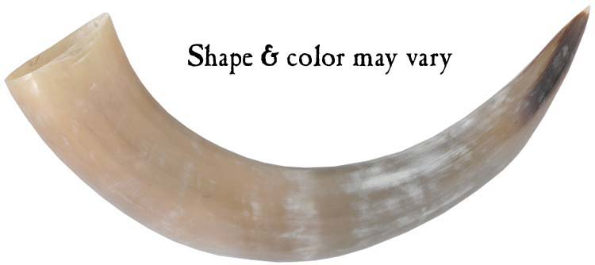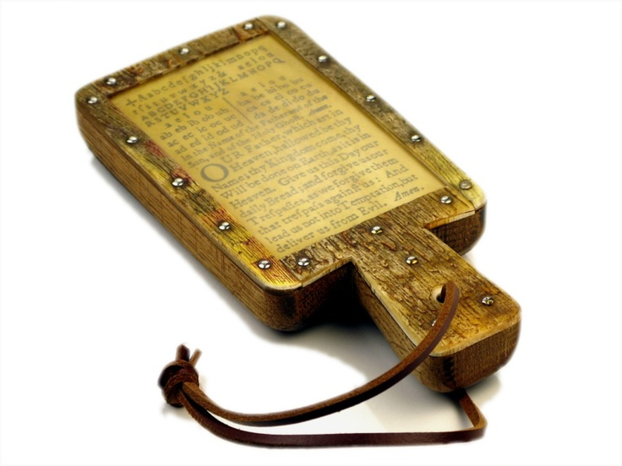

In conclusion, I hope you have the chance to visit the Farmstead Museum. Oh, and also, they have no bathrooms (other than Port-a-Potties). Be warned! And talking about bathrooms, one of the guides said that the Bement family couldn’t afford toilet paper, so they used empty corn cobs! EEW! I was really happy that I had the chance to go to the Farmstead Museum because I really learned a lot about living in that specific time period.

